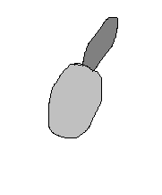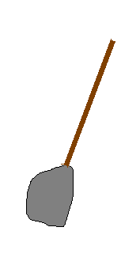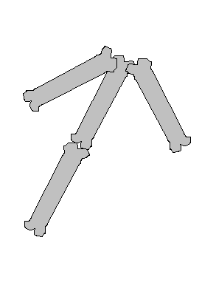Help Wanted
If you want to sign up for a part time job as an archaeologist
or anthropologist now is your chance. You will be paid
$10.00 every 5 hours. All you need is a trowel and you brain.

